|  |  |
| --- | --- |
| school-learn-study-hat-graduate-512.png | ***Study*** |

Read Chapter 5, section 5.1, 5.3, 5.5, 5.6, 5.7 and 5.10 of “How to Think Like a Computer Scientist: Learning with Python 3”:

<http://www.ict.ru.ac.za/Resources/cspw/thinkcspy3/thinkcspy3.pdf>

And then answer the following questions:

1. What is Boolean? Write down 3 different expression that results a Boolean type (i.e. 5 == 6)

Boolean: trạng thái của máy tính, có giá trị là 0:False hoặc 1:True

Ví dụ: 2==3:False

2\*2==4 : True

1+1==2 : True

1. What is a flow chart? Draw flow chart for the following code snippet: (you can draw on a paper, take a picture of it)

Flow chart là sơ đồ luồng thực hiện của code, thường có điểm bắt đầu, điểm kết thúc, câu điều kiện rẽ nhánh đúng sai, vòng lặp… thể hiện logic của chương trình hoặc đoạn code

if name == “Huy be":

print(“Hand some")

elif name == “Huy big":

even\_more\_handsome = True

else:

webbrowser.open(“<https://www.youtube.com/watch?v=04854XqcfCY>”)

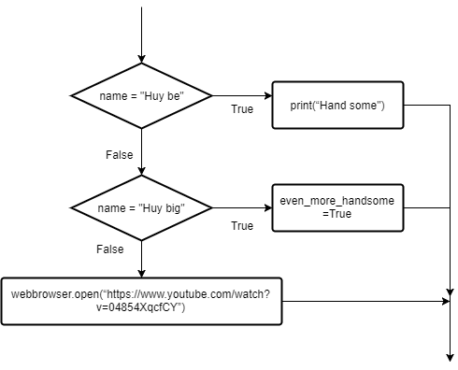

1. What is nested conditionals? Write a piece of code that uses nested conditionals

Nested conditionals: câu điều kiện lồng nhau, tức là trong một câu lệnh rẽ nhánh có chứa một hoặc nhiều câu lệnh rẽ nhánh bên trong nó

if weather == "Mưa":

print("Trời mưa đấy chúng mày ạ!")

if vehicle == "Xe máy":

action = "Nghỉ khỏe, mua áo mưa về nhà cho lành"

elif vehicle == "Ô tô":

action = "Nghỉ khỏe, đi ra đường bẩn xe!"

else:

action = "Nghỉ khỏe, cởi quần áo ra vẫn ướt"

else:

action = "Nghỉ khỏe, trời nắng này học thế nào được"

|  |  |
| --- | --- |
| http://www.bestappsforkids.com/wp-content/uploads/2012/04/save-turtle.png | ***Turtle exercises*** |

Using turtle to draw the following shapes:

|  |  |
| --- | --- |
| Screen Shot 2015-12-25 at 04.41.55.png | 2.  Hi-CBUEkYGb-DOPBqc1p-_os3fG83P3OxHLgEhilkO4 |
|  |  |

|  |  |
| --- | --- |
| 6iporAnbT.jpg | ***Serious exercises*** |

1. Write a program that asks user their height (cm) and weight (kg), and then calculate their BMI (Body Mass Index):

BMI = mass (kg) / (height(m) x height(m) )

Note: you must do the conversion from cm to m before calculation

Then based on the BMI, tell them that they are:

* Severely underweight if BMI < 16
* Underweight if BMI is between 16 and 18.5
* Normal if BMI is between 18.5 and 25
* Overweight if BMI is between 25 and 30
* Obese if BMI is more than 30

1. Study how to print without moving to a new line

Each time we call print(...) to print out something, python will automatically move to a new line, for example, the following snippet:

print("Hello")

print(",my name")

print("is B-max")

will result:

Hello

,my name

is B-max

Your task: Try to search and learn how to print without moving to new line,:

print("Hello", ...)

print(",my name", ...)

print("is B-max", ...)

# "..." is the piece of code you would add

so that the result would be

Hello,my name is B-max

1. Print out the following patterns, remember that the number of columns and rows can be changed later, so try to write programs that scale
   1. 40 x 1 stars (could be 20 x 1 or 50 x 1 or whatever)

\* \* \* \* \* \* \* \* \* \* \* \* \* \* \* \* \* \* \* \* \* \* \* \* \* \* \* \* \* \* \* \* \* \* \* \* \* \* \* \*

* 1. 40 stars and xs (could be 20 x 1 or 50 x 1 or whatever)

x \* x \* x \* x \* x \* x \* x \* x \* x \* x \* x \* x \* x \* x \* x \* x \* x \* x \* x \* x \*

* 1. You can use **print()**, (yes, print with **nothing inside the parentheses ()**) to move to new line, try it
  2. 10 x 10 stars (could be 20 x 30 stars or any size you might like)

x \* x \* x \* x \* x \*

\* x \* x \* x \* x \* x

x \* x \* x \* x \* x \*

\* x \* x \* x \* x \* x

x \* x \* x \* x \* x \*

\* x \* x \* x \* x \* x

x \* x \* x \* x \* x \*

\* x \* x \* x \* x \* x

x \* x \* x \* x \* x \*

\* x \* x \* x \* x \* x

|  |  |
| --- | --- |
| system_config_boot.png | ***Tools preparation*** |

Git is a tool that many professional programmers use to store, keep track and share code with teammates. Using git, one could:

* Store their code online so that in case their machine has problems, they always has backup code
* Share code among team, and still know exactly whom writes which pieces of code and when they write it
* Track code changes, so that if something goes wrong, they could know what changes cause the troubles and could even go back to their old code.

Learn how to use git by watching this tutorial:

<https://www.youtube.com/watch?v=2ftHHNBT4dU>

Then do the following:

* Create an github.com account
* Create a repository in your github
* Use source tree to clone your repo into your PC
* Send your repository link along with your homework